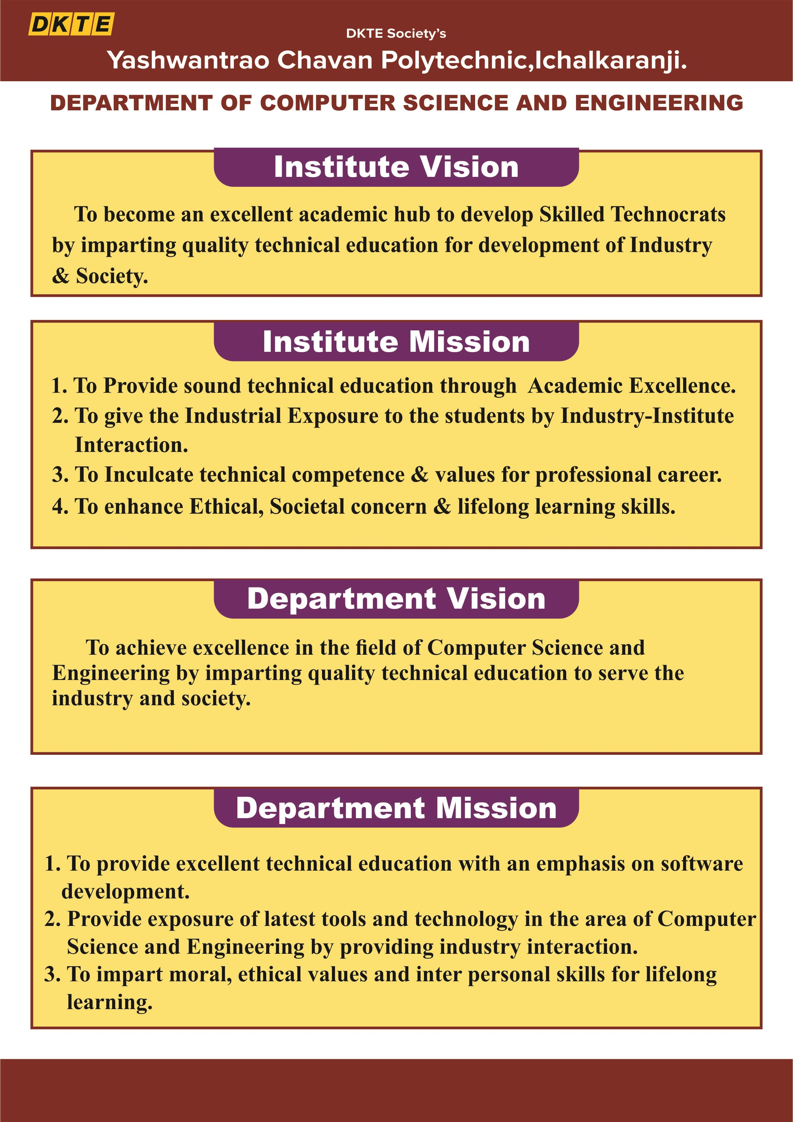

D.K.T.E. Society’s

Yashawantrao Chavan Polytechnic, Ichalkaranji.
Department of
Computer Science and Engineering A
REPORT ON,

“INTERNSHIP”
SUBMITTED BY,

Roll No | Enrolment No. | Exam Seat No. | Student Name
48 | 24213200231 |  | Atharv Milind Suryavanshi

Under the Guidance of
Mrs. S. M. Mali
Academic Year: 2026-27


D.K.T.E. SOCIETY’S

YASHAWANTRAO CHAVAN POLYTECHNIC, ICHALKARANJI.
DEPARTMENT OF

COMPUTER SCIENCE AND ENGINEERING
CERTIFICATE

THIS IS TO CERTIFY,

Roll No | Enrolment No. | Exam Seat No. | Student Name | Sign
48 | 24213200231 |  | Atharv Milind Suryavanshi

HAVE SUCCESSFULLY COMPLETED THE PROJECT DESIGN WORK ENTITLED,

“INTERNSHIP”
In partial fulfilment of Diploma in Computer Science and Engineering at MSBTE, Mumbai.
DATE:
PLACE: ICHALKARANJI

Mrs. S. M. Mali Mr. R. A. Hatgine Mr. A. P. Kothali

(MENTOR) (HOD) (PRINCIPAL)

(EXTERNAL Examiner)

ACKNOWLEDGEMENT
An endeavor over long period can be successful only with advice and guidance of many well-wishers. We thanks to HOD Mr. R. A. Hatgine, of Computer Science and Engineering for this opportunity. We would like to thank the Computer Science and Engineering department for assistance and constant source of encouragement.
We wish to express our profound and deep sense of gratitude to Mrs. S. M. Mali for sparing their valuable time to extend help in every step of our project.

Name of Student:
Atharv Milind Suryavanshi

ABSTRACT

The 12-week Industrial Internship was successfully completed at SoftTech Computer Training Institute with the objective of gaining practical knowledge in Data Science, Data Analysis using Python, Microsoft Power BI, Power Query Editor, DAX, and Generative AI. The internship was designed to bridge the gap between academic learning and industry requirements through hands-on training, practical assignments, and real-world projects.
During the internship, comprehensive training was received in Python programming, covering programming fundamentals, object-oriented programming, exception handling, file handling, and data analysis using NumPy, Pandas, Matplotlib, and Seaborn. Practical experience was gained in data cleaning, preprocessing, exploratory data analysis (EDA), feature engineering, and data visualization using real-world datasets.
The internship also focused on Business Intelligence and Microsoft Power BI, where interactive dashboards and reports were developed using a variety of visualizations. Hands-on experience was gained in Power Query Editor for data transformation, cleaning, merging, and preprocessing, while DAX (Data Analysis Expressions) was used to create calculated columns, measures, and analytical reports for effective business decision-making.
In addition, exposure was provided to Generative AI tools such as ChatGPT, Google Gemini, and Microsoft Copilot, along with professional communication, Git, GitHub, and workplace practices. The successful completion of assignments, exploratory data analysis projects, and Power BI dashboard projects significantly enhanced technical knowledge, analytical thinking, and problem-solving skills.
This report presents the training activities, software tools, projects completed, and practical experience gained during the internship. The internship strengthened my foundation in Python, Data Analytics, Power BI, Power Query, and DAX, while improving my professional skills and preparing me for a career in Data Science, Data Analytics, and Business Intelligence.
.

INDEX

CHAPTER NO. | TITLE | PAGE NO.
1. | Organization Structure of SoftTech Computer Training Institute and General Layout | 1 – 2
2. | Introduction to SoftTech Computer Training Institute (History, Vision, Services, Training Programs, Infrastructure and Organization Details) | 3 – 7
3. | Major Hardware, Software, Development Tools and Technologies Used During Internship (Python, VS Code, Jupyter Notebook, Power BI, NumPy, Pandas, Matplotlib, Seaborn, Git & GitHub, AI Tools) | 8 – 14
4. | Training Methodology, Learning Process and Data Science Workflow (Python Programming, Data Analysis, Data Cleaning, EDA, Business Intelligence, Power BI Development) | 15 – 21
5. | Testing Procedures, Project Validation and Data Processing Techniques (Python Programs, Dashboard Testing, Data Validation, Power BI Report Verification) | 22
6. | Safety Procedures, Professional Ethics, Data Security and Best Practices Followed During the Internship | 23
7. | Practical Experience Gained During the Internship (Python Programming, Data Analysis, Data Visualization, Power BI Dashboard Development and Generative AI Applications) | 24
8. | Detailed Report of Tasks Undertaken During the 12-Week Internship | 25 – 27
9. | Challenges Faced During the Internship, Solutions Implemented and Learning Outcomes | 28
10. | Conclusion | 29
11. | References / Sources of Information | 30

